Norm | RCN-217  RailCom  DCC-Rückmeldeprotokoll
Ausgabe  02.12.2018 | RCN-217  RailCom  DCC-Rückmeldeprotokoll | RailCommunity – Verband  der Hersteller Digitaler  Modellbahnprodukte e.V.
Contents
1 General 3
1.1 Purpose of the Standard 3
1.2 Requirements 3
1.3 Explanations 3
2 Physical Layer 4
2.1 General 4
2.2 RailCom transmitter in the decoder 5
2.3 The RailCom Detector 5
2.4 Timing 6
2.5 4/8 Encoding 8
3 Packet Layer 9
3.1 RailCom command MOB decoder 10
3.2 RailCom command type STAT 11
4 RailCom CVs and DCC Commands 13
4.1 System Requirements 13
4.2 CVs 13
4.2.1 CV28 RailCom Configuration 13
4.2.2 CV29 13
4.2.3 CV31, CV32 14
4.2.4 RailCom Block 14
4.3 DCC Commands 15
4.3.1 Additional function 15
4.3.2 Advanced Programming 15
4.3.3 NOP for Accessory Decoder 16
5 Applications Layer for Vehicle Decoder 18
5.1 POM (ID 0) 18
5.1.1 Byte Read 18
5.1.2 Byte Write 18
5.1.3 Bit Write 19
5.2 ADR (IDs 1 & 2) 19
5.3 Dynamic channel 1 usage 20
5.3.1 Aufgleissuche 20
5.4 EXT (ID 3) 21
5.4.1 Send the location information 21
5.4.2 fill 22
5.5 DYN (ID 7) 22
5.5.1 XPOM Byte Read 25
5.5.2 Byte Write 25
5.5.3 Bit Write 25
5.6 Test Feature ID (ID 12) 26
5.6.1 List of previously issued Test Feature IDs 26
6 Application for accessory decoder (switches, etc.) 26
6.1 SRQ - Service Request for Accessory Decoder 26
6.2 POM (ID 0) 28
6.2.1 Byte Write 28
6.2.2 Byte Write 28
6.2.3 Bit Write 29
6.3 STAT1 (ID 4) 29
6.4 TIME (ID 5) 29
6.5 ERROR (ID 6) 30
6.6 DYN (ID 7) 31
6.7 XPOM (ID 8 to ID 11) 32
6.8 STAT2 (ID 8) 32
Appendix A: References to other Standards 33
A.1 Links to Referenced RCN‘s 33
A.2 Informative Links 33

General

Purpose of the Standard
This standard describes the transmission of data from the decoder over the track to a receiver, ie in the opposite direction to the control protocols. The transmission method described here together with the protocol used is called RailCom.
"RailCom" is a German brand registered in the name of Lenz Elektronik for the class 9 "Electronic Controls" under the number 301 16 303 as well as for the classes 21, 23, 26, 36 and 38 "Electronic Controls for Model Railways" in USA it’s registered under trademark No. 2,746,080. European Patent 1 380 326 B1 was repealed. RailCom is thus freely usable under consideration of the trademarks.
This specification applies exclusively to the use of RailCom within the DCC data format (protocol). The use of RailCom within other data formats is not permitted.

Requirements
In order to comply with this standard, all technical values ​​and protocols defined in this standard must be complied with. Tables 5 and 6 define a minimum set of messages a decoder should support.

Explanations
- A DCC data packet is a defined sequence of bits described as a track signal in [RCN210].
- Bytes are bit groups of eight bits each.
- Each bit in the byte has a significance dependent on its position, the first transmitted bit, the leftmost bit in the representation has the highest significance and is called the "most significant bit" (MSB). The bits of a byte are numbered starting from the left beginning with 7, falling right to 0. The last bit transmitted in the representation is called "least significant bit" (LSB).
- The following characters are used to indicate the meaning of a bit:
0 Bit value 0
1 Bit value 1
A Address bit
D data bit
P Location information (position)
R Direction bit
S Sequence number
T Type of location information
X Subindex
The characters used in the DCC commands are not listed here.
The bit combinations for DCC represented in the box in this standard are purely informative and have no normative character. Only the specified RCNs apply here.
The commands from the Command Station to the decoder (►) are noted in each case without the addressing data. The addressing is done according to the DCC standard.
(◄) depicts the sent RailCom data.
Unless otherwise stated, values ​​always refer to an 8-bit field. Binary values ​​are marked according to section 1.3. Hexadecimal values ​​are indicated by a prefix 0x.

Physical Layer
This chapter describes the physical layer of RailCom.

General
The flow of information in the DCC system normally takes place from the central booster (usually a command station) over the track to the decoders. For the decoder to transmit to the Command station using RailCom it is necessary to interrupt the DCC signal. This is done by the boosters, which generate a „RailCom cutout“ at the end of each DCC packet. The cutout created by disconnecting the two track lines from the power supply and short them together. This devices that can create said cutout are "cutout devices". A cutout device could also be run as a separate unit outside the booster. The actual data transmission takes place by means of a current loop. The decoder must store enough power to source the needed current during the cutout window. Figure 1 shows the arrangement of a booster, detector and decoder during the RailCom cutout. Detectors can detect the RailCom signal and display or retransmist the data as needed, for example a detector may display the address of the decoder in its block. Detectors can be standalone devices or part of a booster, command station, etc. 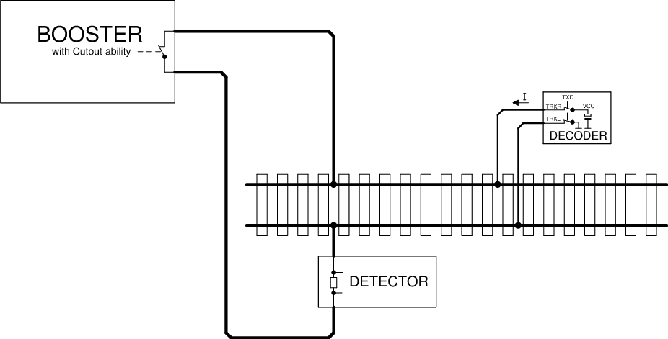
Figure 1: RailCom schematic diagram
The voltage drop across the cutout device must not exceed 10mV at a maximum of 34mA during the cutout.

RailCom transmitter in the decoder
In order to transmit a '0', the decoder must deliver a current I of 30 +4 or -6 mA, with a voltage drop on the track of up to 2.2 V. If high-current RailCom is enabled in CV28, the decoder Current must be within +8mA to -12 mA of 60mA, a voltage drop on the track of up to 2.2 V is allowed. For a '1' the current I may not exceed ± 0.1 mA. The power source of the decoder must be protected against unexpected external voltage on the track during cutout. Figure 2 shows a possible decoder hardware implementation.
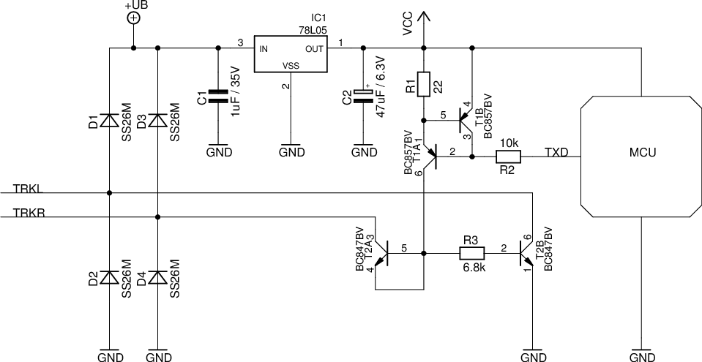
Figure 2: RailCom Decoder Hardware

Explanation of the circuit diagram:
The RailCom circuitry consists only of the resistors R1 to R3 and the transistors T1A to T2B. T1A and T1B form a current source, T2A is diode-connected and protects the current source from positive voltages higher than Vcc.
All other parts of the circuit are normally necessary hardware of a decoder. Note the extremely low hardware costs for the RailCom transmitter.

The RailCom Detector
A Detector must interpret a current greater than 10mA as '0' during the middle 50% bit time, a current less than 6mA during the middle 50% bit time as '1'. The voltage drop across the detector should not exceed 200mV at a maximum of 34mA during the cutout. Figure 3 shows a possible hardware circuit:
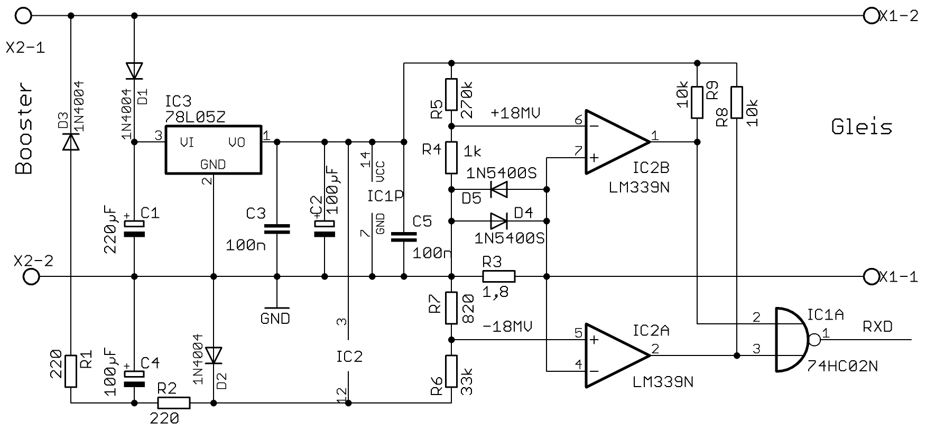
Figure 3: Example of a simple RailCom Detector Hardware
A maximum of two detectors (including the global detector) may be used in series, whereby the local detector should contain a connection for external evaluation of a track occupancy. If this is not the case, externally used occupancy detectors must be specified for RailCom. Explanation:
The transmitters and detector circuits were tested on large club facilities up to a distance of 100 meters. This distance was easily bridged. It is not possible to use 5 ohm loads isolated from the track by bridge rectifiers, which are parallel to the measuring resistor of the detector.
The value of 5 ohms corresponds to a current of 3A at a track voltage of 15V.
Incandescent lamps (PTC thermistors) must always be operated via a fast bridge rectifier (<500 ns)..

Timing
Up to 8 bytes of data can be transferred in one cutout. Each transmitted byte begins with a start bit ('0') followed by the 8 data bits (least significant bit first) and ends with a stop bit ('1'). The transmission rate is 250 kbit / s ± 2%. The rise time (10% → 90%) and fall time (90% → 10%) must not exceed 0.5 μs.
The RailCom Cutout is divided into two channels. In channel 1 two bytes, in channel 2 up to six bytes can be transmitted. Figure 4 shows the timing diagram. All times are related to the zero crossing of the last edge of the packet end bit.
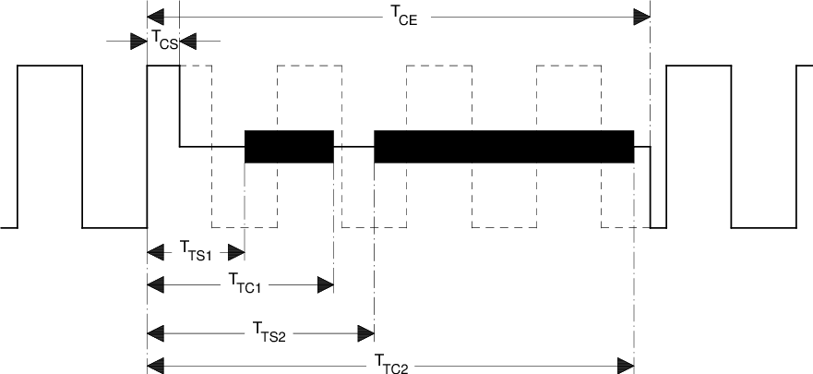
Figure 4: RailCom Timing

Parameter | Name | Min | Max
Cutout Start | TCS | 26µs | 32µs
Cutout End | TCE | 454µs | 488µs
Start Channel 1 | TTS1 | 80µs
End Channel 1 | TTC1 |  | 177µs
Start Channel 2 | TTS2 | 193µs
End Channel 2 | TTC2 |  | 454µs
Table 1: Timing Parameters
Comment:
The above figure shows the RailCom timing with "1" bits of 2 * 58μs (nominal value of the DCC "1" bit). For shorter "1" bits, it is possible for the cutout to reach the 5th "1" bit. However, this is not a problem since a Command Station must send at least 4 + 12 = 16 sync bits according to [RCN211] (packet end bit of the previous DCC packetbitsbits not counting the), so the decoder has enough sync(at least 11 syncmust be sent) for a recognition of the package by the decoder required) sees.
A cutout time of approx. 450μs must not affect the function of a decoder that does not support RailCom, as current interruptions up to 20ms have been detected on a real model railway layouts, ie a decoder should be able to process at least one power interruption on this scale.

4/8 Encoding
Transmission integrity is ensured via a 4/8 encoding scheme, ie each transmitted byte contains 4 '1' and 4 '0' bits. If this ratio is violated, there is a transmission error.
There are 70 different bit combinations within a byte that have this ratio 4: 4. Of these, 64 are used for the transmission of 6 useful bits, of the remaining 6 one is used for short special messages, ACK. The remaining five combinations are reservered for future use.
It is possible to transfer up to 12 bits of user data in channel 1 and up to 36 bits in channel 2.
The possible 4/8 encodings are:
Value | 4/8 Code | Value | 4/8 Code | Value | 4/8 Code | Value | 4/8 Code
0x00 | 10101100 | 0x10 | 10110010 | 0x20 | 01010110 | 0x30 | 11000110
0x01 | 10101010 | 0x11 | 10110100 | 0x21 | 01001110 | 0x31 | 11001100
0x02 | 10101001 | 0x12 | 10111000 | 0x22 | 01001101 | 0x32 | 01111000
0x03 | 10100101 | 0x13 | 01110100 | 0x23 | 01001011 | 0x33 | 00010111
0x04 | 10100011 | 0x14 | 01110010 | 0x24 | 01000111 | 0x34 | 00011011
0x05 | 10100110 | 0x15 | 01101100 | 0x25 | 01110001 | 0x35 | 00011101
0x06 | 10011100 | 0x16 | 01101010 | 0x26 | 11101000 | 0x36 | 00011110
0x07 | 10011010 | 0x17 | 01101001 | 0x27 | 11100100 | 0x37 | 00101110
0x08 | 10011001 | 0x18 | 01100101 | 0x28 | 11100010 | 0x38 | 00110110
0x09 | 10010101 | 0x19 | 01100011 | 0x29 | 11010001 | 0x39 | 00111010
0x0A | 10010011 | 0x1A | 01100110 | 0x2A | 11001001 | 0x3A | 00100111
0x0B | 10010110 | 0x1B | 01011100 | 0x2B | 11000101 | 0x3B | 00101011
0x0C | 10001110 | 0x1C | 01011010 | 0x2C | 11011000 | 0x3C | 00101101
0x0D | 10001101 | 0x1D | 01011001 | 0x2D | 11010100 | 0x3D | 00110101
0x0E | 10001011 | 0x1E | 01010101 | 0x2E | 11010010 | 0x3E | 00111001
0x0F | 10110001 | 0x1F | 01010011 | 0x2F | 11001010 | 0x3F | 00110011
ACK | 00001111 | "Command is understood and will be executed "or" YES "
ACK | 11110000 | "Command is understood and will be executed "or" YES "
Reserved | 11100001
Reserved | 11000011
Reserved | 10000111
NACK | 00111100 | "Command or CV is not supported" - optional
Table 2: 4/8 Encoding

Detailed explanation of NACK:
This optional response states that a command is not supported. The detection of an unsupported command is restricted to the In POM (regardless of the response to unimplemented instructions), a NACK may also be sent to identify a non-existent CV. To keep from saying that PoM is not supported a NACK must not be the first response when responding to a POM command, ie when accessing a non-existent CV, an ACK and then a NACK mst be sent. ACK and NACK can be sent together in the same channel 2 cutout.

Packet Layer
This chapter describes the structure of RailCom Datagram
RailCom packets (hereinafter referred to as datagrams) have a length of 6, 12, 18, 24 or 36 payload bits, only a 12-bit datagram can be transmitted. In channel 2, any combination of datagrams with a maximum total length of 36 bits can be transmitted.
Optionally, the data channel can be filled with ACK to 36 bits.
Datagrams (except ACK) begin with a 4-bit identifier followed by 8, 14, 20, or 32-bit payload data, as follows:
Datagram | Bytes
12 Bit | ID[3-0]D[7-6]+D[5-0]
18 Bit | ID[3-0]D[13-12]+D[11-6]+D[5-0]
24 Bit | ID[3-0]D[19-18]+D[17-12]+D[11-6] +D[5-0]
36 Bit | ID[3-0]D[31-30]+D[29-24]+D[23-18]+D[17-12]+D[11-6] +D[5-0]
Table 3: Datagram Structure
The length of the datagram is determined by the identifier. The identifiers are defined below
Mobile Decoder (vehicle decoder) and stationary decoder (accessory decoder) have different feedback requirements. Accordingly, the channels are used differently for both types of decoders. The meaning of the datagrams therefore depends on the address of the preceding DCC packet. There are also system requirements that all decoders have to. For this purpose, the DCC address 255 is set as "system address". Accordingly, the following RailCom command types MOB (mobile) and STAT (stationary) are distinguished on the basis of the DCC address ranges as defined in [RCN211] Section 3:

DCC Address |  | RailCom Command type
1st Byte | 2nd Byte | RailCom Command type
1-127 |  | MOB (mobile) Short address
128-191 |  | STAT (accessory)
192-231 | ADR low | MOB (mobile) Long address  The long address 3 is also used as a programming address.
255 |  | MOB / STAT  255 is the address of the idle packet (0xFF 0x00 0xFF)  The 1st data byte other than 0 indicates the use as the system address. In any case, the packet then consists of more than 3 bytes.
Table 4: Command and system
Decoders are not allowed to send feedback to other addresses or service mode packets.

RailCom command MOB decoder
Channel 1 is used for locating mobile decoders on the layout (see app: adr). To do this, they must send their DCC address after every DCC packet sent to a mobile decoder, which is then received by local detectors on the layout. Mobile decoders must not sent their address in response to programming mode packets (from the time the decoder recognizes the programming mode packets)
Channel 2 may only be used by the addressed decoder and is used to transmit decoder information. An addressed decoder must always send feedback in channel 2 (ACK if necessary) to confirm the error-free reception of the DCC packet.
A response in channel 2 indicates that the decoder received the command without error, but not that the decoder accepts and executes the command.
The following identifiers (datagrams) are defined for mobile decoders:
ID | Channel 1 | Channel 2 | Comment | Command Related
0 |  | app:pom | mandatory, 1 Byte | yes
1 | app:adr_high | app:adr_high | mandatory in Channel 1 | yes
2 | app:adr_low | app:adr_low | mandatory in Channel 1 | yes
3 |  | app:ext | optional | yes
4 |  |  | reserved
5 |  |  | reserved
6 |  |  | reserved
7 |  | app:dyn | optional | no
8 |  | app:xpom &  app:CV-auto | optional  optional | yes  no
9 |  | app:xpom | optional | yes
10 |  | app:xpom | optional | yes
11 |  | app:xpom | optional | yes
12 |  | app: Test Feature ID | optional | n/a
13 |  | app:block | optional | yes
14 |  |  | reserved
15 |  |  | reserved
Table 5: Command type MOB Identifier (Datagrams)
"Mandatory" means full implementation
"Optional" either full implementation or partial implementation with the conditions under 4.1 related
"Command Related" with "yes" the messages in channel 2 may only be assigned to a corresponding command consequence; with "no" after any command to the decoder. These non-command responses are also considered ACK.
Note:
Older decoders have used different identifiers during a test phase, which are now marked as "reserved". Newer decoders must have entered the RailCom version number in a special CV (see section "RailCom CVs"). This can be used to determine what decoder supports what identifiers. Older decoders without version numbers should be updated.

RailCom command type STAT
The RailCom specification for accessory decoders is not yet completed. All information is to be regarded as provisional.
Accessory decoders use channel 1 to report service request requests (see app: srq). To do this, you can send your identity (12-bit address) after each DCC packet directed to an accessory decoder (12-bit value without identifier !!) (not for addressing via decoder ID). If several decoders register at the same time, a search must be started.
Channel 2 may only be used by the addressed decoder and is used to transmit decoder information. An addressed decoder must always send a feedback in channel 2 (ACK if necessary) to confirm the error-free reception of the DCC packet.
A response in channel 2 indicates that the decoder received the command without error, but not that the decoder accepts and executes the command.

The following identifiers (datagrams) are defined for accessory decoders:
ID | Channel 1 | Channel 2 | Comment | Command Related
 | app:srq |  | optional
0 |  | app:pom | optional | no
1 |  |  | reserved
2 |  |  | reserved
3 |  |  | reserved
4 |  | app:stat1 | mandatory | no
5 |  | app:zeit | optional | no
6 |  | app:fehler | mandatory | no
7 |  | app:dyn | optional | yes
8 |  | app:xpom (alt: stat2) | optional | no
9 |  | app:xpom | optional | no
10 |  | app:xpom | optional | no
11 |  | app:xpom | optional | no
12 |  | app: Test Feature ID | optional | n/a
13 |  | app:block | optional | no
14 |  |  | reserved
15 |  |  | reserved
Table 6: Command type STAT Identifier (datagrams)
"Mandatory" → means complete implementation
"optional" → either complete implementation or: partial implementation with the conditionsunder 4.1 related
specified"Command-"with "yes", the messages in channel 2 must only have one follow corresponding command; with "no" after any command to the decoder. These non-command responses are also considered ACK.

RailCom CVs and DCC Commands

System Requirements
This RailCom specification is designed to be backwards compatible, ie non-RailCom decoders can continue to operate, and non-RailCom capable command stations can continue to control RailCom-enabled decoders.
The driving of analog locomotives (locomotives without a decoder) with the help of the extended "0" (stretched zero) is not permitted.
A decoder that supports Railcom must implement the following features: APP.ADR; APP.POM; ACK
Every Mobile or Stationary decoder must respond in channel two of the cutout when the packet is addressed to it.
Auf jede Fahrzeug- bzw. Weichen- Adressierung muss der Decoder im Kanal 2 der Austastlücke antworten (siehe Applikationen).

CVs

CV28 RailCom Configuration
Bit | Function
0 | Channel 1 for Address-Broadcast (Section 5), 1 = enabled, 0 = disabled
1 | Channel 2 for Data and Acknowledge, 1 = enabled, 0 = disabled
2 | Disable channel 1 automatically (Section 5.2.1 ) 1 = enabled, 0 = disabled
3 | Reserved
4 | Programming address 0003 (long address 3) , 1 = enabled, 0 = disabled
5 | Reserved
6 | Enable high-current RailCom (section 2.2) 1 = enabled, 0 = disabled
7 | Release RailComPlus, 1 = enabled, 0 = disabled
Table 7 RailCom Konfiguration.
To be compatible with previous behavior, CV28 bit 2 should be 0 when a decoder is shipped. The factory default value of bit 0 should be 1 for mobile decoders and 0 for accessory decoders. The value of bit 1 for all decoders should be 1.

CV29
Use According to [Error: Reference source not found].

CV31, CV32
Use according to [Error: Reference source not found].

RailCom Block
CV31 = 0 and CV32 = 255 address a block of 256 CVs, which are used for RailCom applications according to the following table:
Byte | Purpose | Mandatory/  Optional | Read/  Write
0 | Manufacturer ID (from NMRA [S-9.2.2 Appendix A]) | m | R
4-7 | Product ID (Manufacturer-specific product identifier to distinguish the individual products Little Endian) | o | R
8-11 | MUN (Manufacturer Unique Number, Little Endian)  4 byte serial number unique over all devices of one manufacturer. | o | R
12-15 | Production(number of seconds since 1.1.2000, Little Endian, Unsigned) | o | R
16-63 | Manufacturer-assignment possible | o | R/W
64-127 | Dynamic variables according to APP DYN, Section 5.4, Table 11  72 - Container 1  ...  83 - Container 12 | o | R/W
128 | RailCom Version number "Major revision", binary | m | R
129 | RailCom Version number "Minor revision", binary | m | R
130 | Feature number for test feature ID (see 5.5) | o | R
131 | Reserved
132 | specific consumption, container 1 | o | R/W
133 | specific consumption, container 2 | o | R/W
134 | specific consumption, container 3 | o | R/W
135 | specific consumption, container 4 | o | R/W
136 | specific consumption, container 5 | o | R/W
137 | specific consumption, container 6 | o | R/W
138 | specific consumption, container 7 | o | R/W
139 | specific consumption, container 8 | o | R/W
140 | specific consumption, container 9 | o | R/W
141 | specific consumption, container 10 | o | R/W
142 | specific consumption, container 11 | o | R/W
143 | specific consumption, container 12 | o | R/W
144 | Level of all containers (0 ... 255), a write command to this CV sets the contents of all containers to the specified value. | o | W
145 | speedometer scaling in the control panel,  value times 2 = maximum speed in km / h or mph | O | R/W
146-255 | Reserved
Table 8: Railcom Block CV Descriptions
m = Mandatory, o = Optional, R = Read, W = Write

DCC Commands
RailCom's enhanced functionality also requires additional DCC commands. These include:

Additional function
RailCom offers additional functions such as a search function, track search, etc. (see also "Applications (APP) layer for mobile decoder"). Short form binary state control commands are use according to [RCN212] section 2.3.5.
Operation command: Binary state control as RailCom command
► | Short binary state control command according to ([RCN212]) Section 2.3.5  1101-1101 DLLL-LLLL
These commands are referred to as XF1 (extra function) through XF127 in this standard.
Of these commands, the first 28 are reserved for special applications such as RailCom in [RCN212]. For RailCom, the first 15 functions are defined.
XF = | Function:
1 | requesting the location information corresponding to section 5.3.1
2 | Track Search
3 - 15 | Reserved
Table 9: Function Numbers

Advanced Programming
There is a method in [RCN214] Section 3 to write „CV Pairs“ simltanously.
KKKK = 0100 = Write CV17 (first data byte) and CV18 (second data byte) (extended address) simultaneously, and set bit 5 in CV29.
Feedback occurs at the old address via two consecutive datagrams with ID0, first the first data byte, then the second data byte. Both datagrams must be sent in the same channel 2, ie 12-bit datagram + 12-bit datagram.
Operation: POM
► | commandWrite CV access from CV17 and CV18 according to [RCN214] section 3  1111-0100
◄ | Channel 2: 0000 (ID0) DDDD-DDDD + 0000 (ID0) DDDD-DDDD  with D = CV data, first CV17 , then CV18
KKKK = 0101 = write CV31 (first byte of data) and CV32 (second byte of data) (extended range, high byte (31), and low byte (32) pointer value).
Feedback occurs via two consecutive datagrams with ID0, first the first data byte, then the second data byte. Both datagrams must be sent in the same channel 2, ie 12-bit datagram + 12-bit datagram.
Operation: POM
► | commandWrite CV access from CV31 and CV32 according to [RCN214] section 3  1111-0101
◄ | Channel 2: 0000 (ID0) DDDD-DDDD + 0000 (ID0) DDDD-DDDD  with D = CV data, first CV31 , then CV32decoderpanel

NOP for Accessory Decoder
Accessory decoders will report for a switching command if they want to communicate something to the command station (SRQ).
Normally, switching commands are only sent sporadically, so accessory decoders may only be noticeable just as rarely. Therefore, in Section 2.5 of [RCN213], the NOP command is defined to be sent on a regular basis, but initially does nothing to allow SRQ except accessory decoders.
This must be recognized as invalid by all non-RailCom-compatible simple and extended accessory decoders and thus ignored. On the one hand, it allows accessory decoders to issue an SRQ in the subsequent blanking interval, and on the other hand, it allows for the event that several decoders register simultaneously with an SRQ, as well as the search for the decoders involved.
This is achieved by transmitting an accessory decoder address with the NOP. Thereupon only the decoders whose address is smaller or the same as the ones contained in the NOP are notified. As a result, the decoder with the respective lower address can be found and operated in the case of messages from several decoders by means of successive approximation. The search is repeated until no more decoder announces.

Operation: NOP
► | commandNOP for accessory decoder according to [RCN213] Section 2.5  10AA-AAAA 0AAA-1AATpanel
For regular polling of all accessory decoders, the controlsends a NOP with the highest possible address, so that all decoders are addressed.
As long as only one decoder with an SRQ reports this, it can remain with the highest address in this NOP. Only when several decoders report at the same time, the central office must start a search by suitably varying the address contained in the NOP.
A RailCom-capable center must send a NOP command at certain intervals to query the accessory decoder. The time interval between two NOPs is a compromise of bandwidth limitation on the DCC signal and response time on SRQ messages. An interval of about 0.5 seconds is recommended.
When searching for multiple messages, the NOPs used for the search must of course be sent as quickly as possible in succession.

Applications Layer for Mobile Decoder
The following sections describe the commands for the RailCom functionality.

POM (ID 0)
POM means "Programming On the Main". It is used to read and write configuration variables in the operating mode according to [RCN214] section 2. These commands are respoded to in channel 2 by sending a 12 bit datagram consisting of ID0 = 0000 and 8 data bits. The data bits contain the value of the CV.
Operation: POM
►Track Packet | Command Access to Bytes or Bits According to [RCN214] Section 2  1110-KKVV VVVV-VVVV DDDD-DDDD  1110-10VV VVVV-VVVV 111K-DBBB
◄Railcom Response | Channel 2: 0000 (ID0) DDDD-DDDD  with D = CV-Daten

Byte Read
Operation: POM Byte Read
► Track Packet | Command byte according to [RCN214] Section 2.  1110-01xx
◄ Railcom Response | Channel 2 (12Bit): 0000 (ID0) DDDD-DDDD  mit D = CV-Daten.
The associated response datagram (ID0) does not have to be sent in the cutout immediatly after the command packet but must be sent within 0.5 seconds of the command packet. A Command Station must therefore ensure that the decoder is addressed again and no other programming command is sent to the same address (repeated the command is permitted).
When the read operation is completed, the decoder sends the result to the associated read command. If the decoder does not return the data within 0.5s then the read is considered failed.

Byte Write
Operation: POM Byte Write
► | commandbyte according to [RCN214] Section 2.  1110-11xx
◄ | Channel 2 (12 bit): 0000 (ID0) DDDD-DDDD  Here D is the value returned = CV data after POM Operation is present in the CV.
When writing, the decoder should respond as follows: With ACK, as long as the new value is not written with the new value, if the new value is written successfully, first with ACK and then NACK if the CV is not supported or another one Value if the written value can not be accepted. Instead of an ACK, another non-command message can be used.
If the decoder does not return a value within 0.5s then the write is considered failed. For read only CV‘s the shall decoder return the current value of the CV.

Bit Write
Operation: POM Bit Write
► | Command bit according to [RCN214] Section 2  1110-10xx
◄ | Channel 2 (12 bit): 0000 (ID0) DDDD DDDD  Here, with D = CV data, the value returned after the POM operation in the CV is returned.
The „Bit Read“ command is not implemented because RailCom responds with the whole byte, making a „Bit Read“ not necessary

ADR (IDs 1 & 2)
With the help of fixed detectors, RailCom can be used for localization.
Vehicle decoders use channel 1 as a broadcast channel for their own address. In the cutout after every DCC packet to a vehicle decoder, they send their active address (base, extended or consist address). For this, the following 12-bit datagrams with ID1 and ID2 are defined:
ADR1 (ID1) | ADR2 (ID2) | Addresse
0 0 0 0 0 0 0 0 | 0 A6 A5 A4 A3 A2 A1 A0 | Base -Address (CV1)
0 1 1 0 0 0 0 0 | R A6 A5 A4 A3 A2 A1 A0 | Consists Address (CV19)
1 0 A13 A12 A11 A10 A9 A8 | A7 A6 A5 A4 A3 A2 A1 A0 | Extended Address (CV17+CV18)
Table 10: Address Assignment
A decoder must be on the ADR1 and ADR2 alternately. The "active address" is the one under which the decoder receives its drive commands.
Operations-Response: ADR
► | commandOperation command to decoder according to [RCN212] Section 2
◄ | Channel 1: 0001 (ID1) ADR1 or 0010 (ID2) ADR2
Possible application:
Local Detectors on the system can receive information from decoders and pass that along to a global detector (Command Station, computer, etc.). In this way, the Command Station can learn which decoder is on a particular track section. Figure 5 shows this setup.
This method is suitable for train control.
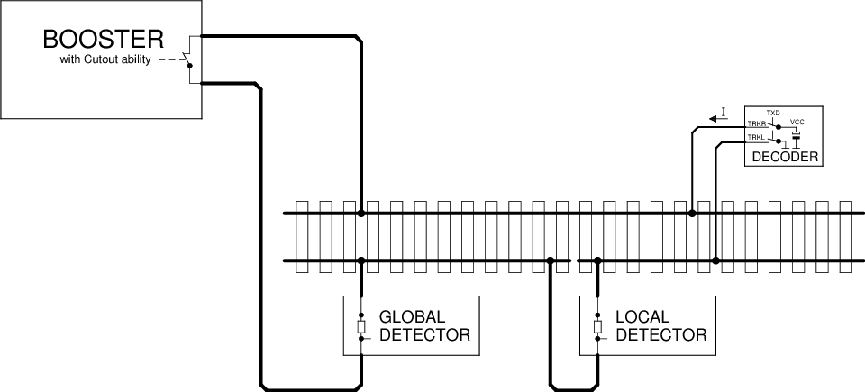
Figure 5: | Localized detector
Decoder locating a decoder in the above pattern can only work if the decoder is on the track section monitored by the Local Detector. However, this is problematic in when multiple locomotives are in a consist. For this it is recommended that only the leading locomotive sends the ADR datagrams on channel 1, while on the following locos this function is deactivated via CV28. This can be done when assembling the consist via POM.

Dynamic channel 1 usage
In this case, the sending of the address in channel 1 is automatically switched off in order to reduce collisions. The decoder transmists in channel 1:
- After a restart
- After a change of address
- If it has not been addressed for more than 5s.
If bit 2 is set in CV28, the transmission in channel 1 will be switched off automatically after receiving eight packets addressed to it. This method will allow for detection of a new locomotive and, once addressed by the system, that locomotive no longer interfere with the detection of other locomotives.

Track Search
This is a special application to identify a decoder on the layout. For this purpose, the decoder is temporarily separated from the track power. After the decoder receives power again, it responds for a maximum of 30 seconds to the command "XF2 off" to broadcast address 0 with its address in Channel 2. During this time, the user must trigger this command via the control panel.
Operating Command Response: EXT
► | short binary state control command "XF2 off" according to [RCN212] section 2.3.5 to the broadcast address 0: 1101-1101 0000-0010
◄ | Channel 2 from the decoder has three 12 bit datagrams  0001 (ID1) DDDD-DDDD : adr_high according to Table 10  0010 (ID2) DDDD-DDDD : adr_low according to Table 10  0000 (ID0) DDDD-DDDD : Time in seconds since the decoder has power again.
The decoder should not respond to every command "XF2 off" to the broadcast address 0, so that collisions in channel 2 may be reduced. These occur when another vehicle unintentionally had no track power for a short time and therefore might respond. Over time since the decoder has tension again, the desired vehicle should be identifiable.
Decoders should not respond to the command „XF2 off“ on broadcast address 0 unless the decoder is powering up, this is to avoid collisions.

EXT (ID 3)
This feedback is used to transmit location information. In this way, the location of the locomotive can be determined and location specific operartions can be triggered such as a filling of inventories (coal, fuel, etc)

Sending of the location information
The location information may be sent by the decoder or the detector, depending on where the information is.
Case 1: Location information is present in the decoder (eg by infrared transmission)..
Operating Command Response: EXT
► | short binary state control command "XF1 off" according to [RCN212] section 2.3.5: 1101-1101 0000-0001
◄ | Channel 2 of the decoder: 0011 (ID3) 00 TTTT-PPPP-PPPP  With: TTTT = 0000 - 0111 : Location information (position):0PPP  TTTT = 1000 - 1111 : reserved  0PPP-PPPP-PPPP : 11 bit location address (position)
If the location information is present in the decoder, it can also be transmitted spontaneously in channel 2 with the ID DYN. See section 5.4.
Case 2: Location information is available in the Detector.
Operating Command Response: EXT
► | short binary state control command "XF1 off" according to [RCN212] section 2.3.5: 1101-1101 0000-0001
◄ | Channel 2 from Decoder:  0011 (ID3) 01 | Channel 2 from Detector:  TTTT-PPPP-PPPP  information  TTTT = 1000 : reserved  TTTT = 1001 : reserved  TTTT = 1 010 : Diesel fuel  TTTT = 1011 : coal bunker  TTTT = 1100 : Water tower  TTTT = 1101 : Sanding station  TTTT = 1110 : Charging station (battery)  TTTT = 1111 : General filling station  PPPP-PPPP : 8 bit location address (position)
The Detector works as in Figure 5, but is supplemented by a RailCom transmitter. Since the location information is sent back across the track, a bus system is not needed.

fill
The filling of a container or all containers takes place with the command "Byte Write" from Section 5.1.2 to the corresponding CVs in the RailCom block (CV31 = 0 & CV32 = 255).

DYN (ID 7)
This feedback is used to transmit dynamic information from vehicle decoders. Dynamic information refers to dynamic variables (DVs) that change during operation (eg speed, tank contents, etc.). RailCom CVs 64-127 (see Section 4.2.4, Table 8) correspond to DVs that can be changed by programming.
Operation Command Response: DYN
► | Operating command to decoder address according to [RCN212] section 2
◄ | Channel 2 18Bit [+ 18Bit]:  0111 (ID7) DDDD-DDDD-XXXX-XX  [ 0111 (ID7) DDDD-DDDD-XXXX-XX ]  with D = DV value and X = subindex for identification of the DV
The transmission of dynamic variables (DV) (eg speed, container, ...) takes place in an 18-bit datagram (ID7), which contains the 8-bit value of the DV ( D ) as well as a 6-bit subindex ( X ) of 64 possible DVs selected. The meaning of the DV is determined by the subindex.
2 arbitrary DVs can be transmitted in a feedback frame. Which DVs a decoder sends when he determines himself.
X | Meaning
0 | Real speed part 1 *  Values ​​between 0 and 255 are sent back from the decoder. 255 is maximum speed. The figures are in km / h (or mph). At higher speeds than 255 the difference is stored in part 2.
1 | Real speed, part 2 *
2 | reserved
3 | reserved
4 | reserved
5 | Flag Register, content yet to be determined
6 | Input register, assignment to be determined
7 | Reception Statistics: The vehicle decoder keeps track of all received DCC packets and transmits the number of bad packets / total in%. (Value range 0-100).
8 | Content of container 1 in% (value range 0-100)
9 | Contents of container 2 in% (value range 0-100)
10 | Content of container 3 in% (range 0-100)
11 | Contents of the container 4 in% (value range 0-100)
12 | Contents of the container 5 in% (value range 0-100)
13 | Contents of the container 6 in% (value range 0-100)
14 | Contents of the container 7 in% (value range 0-100)
15 | Contents of the container 8 in% (value range 0-100)
16 | Contents of the container 9 in% (value range 0-100)
17 | Content of the container 10 in% (value range 0-100)
18 | Contents of the container 11 in% (value range 0-100)
19 | Contents of the container 12 in% (value range 0-100)
20 | Datagram 1: Local address least significant 8 bits  Datagram 2: Local address Most significant 3 bits in bits 0 to 2 ,  bits 3 to 7 are reserved to 0.
21 | Status and alarm messages
22 | Trip odometer, exact definition yet to be determined
23 | Operating time, exact definition yet to be determined
24-63 | reserved
Table 11: Dynamic information vehicle decoder
* Note on transferring the real speed:
For example, the decoder calculates the actual speed on the system. This is multiplied by the scale, adjustable in the decoder is (for example, the value of H0, 87). Result is the real speed. It is transmitted as km / h. Up to the value 255, the transfer takes place exclusively in ID 7 DYN0. If the speed is higher, only the difference (ie calculated speed in km / h minus 256) is transferred to ID 7 DYN 1. ID 7 DYN 0 will not be transmitted because it no longer contains relevant information.
For the location address DV 20, both address parts are to be transmitted separately in 18-bit datagrams within a single channel, transmitting least significant 8 bit datagram first. For addresses <256, a single datagram is sufficient.
The status and alarm messages for DV22 are still to be determined.
The most significant bit determines whether the alarm is active or not.
5.5 XPOM (ID 8 to ID 11)
POM means "Programming On the Main", XPOM is an extended format for writing and reading up to four CVs in operating mode according to [RCN214] Section 5, compared to the POM defined in section 5.1. These instructions are used in channel 2 with a 36 bit datagram with the ID 8 = 1000 to ID 11 = 1011 and 32 data bits. The data bits contain the value of four consecutive CVs.
Operation: XPOM
► | Accessing Bytes or Bits According to [RCN214] Section 5  1110-KKSS VVVV-VVVV VVVV-VVVV VVVV-VVVV {DDDD-DDDD {DDDD-DDDD {DDDD-DDDD {DDDD-DDDD}}}
◄ | Channel 2 (36-bit): 10SS (ID8 - 11) DDDD-DDDD DDDD-DDDD DDDD-DDDD DDDD-DDDD  with D = CV data
Regardless of the number of bytes written and even if only one bit is written, the values ​​of four CVs are always reported back.
The assignment between command and response is carried out by means of sequence number SS and datagram ID as follows:
SS = 00 - ID 8 1000
SS = 01 - ID 9 1001
SS = 10 - ID 10 1010
SS = 11 - ID 11 1011
The response datagram associated with the XPOM command (ID8 ... ID11) does not have to be sent in the same packet frame.
The decoder must implement a queue for 4 XPOM commands and execute them in sequence. Repeatedly sent XPOM commands with the same sequence number are queued only once. The associated response datagram completes the operation and releases the corresponding entry in the queue. When writing via XPOM, the answer will be given after the actual writing process is completed. In this way, the control panel can synchronize to the writing speed of the decoder. If the response datagram is missing, the last command with the same sequence number must be sent repeatedly. When writing read-only CVs, the decoder returns the current value of the CVs. Whether a write access has been accepted must be determined by the command station by comparing the written value and received value.
The decoder must support fast, block-by-block reading, ie, with consecutive XPOM read commands
the answer of the 1st XPOM read command at the latest in the cutout of the
3. XPOM read command to be sent
the answer of the 2nd XPOM read command at the latest in the cutout of the
4. XPOM read command to be sent
the answer of the 3rd XPOM read command at the latest in the cutout of the
5. XPOM read command sent to,
...
In this way is a very quick readout of data is possible.

XPOM Byte Read
Operation: XPOM Byte Read
► | Byte read according to [RCN214] section 5.  1110-01SS VVVV-VVVV VVVV-VVVV VVVV-VVVV
◄ | Channel 2 (36 Bit): 10SS (ID8-11) CV[V+0] CV[V+1] CV[V+2] CV[V+3]
At the time of the feedback, the preceding format must be used.

Byte Write
Operation: POM Byte Write
► | Byte write according to [RCN214] section 5.  1110-11SS VVVV-VVVV VVVV-VVVV VVVV-VVVV {DDDD-DDDD {DDDD-DDDD {DDDD-DDDD {DDDD-DDDD}}}
◄ | Channel 2 (36 Bit): 10SS (ID8-11) CV[V+0] CV[V+1] CV[V+2] CV[V+3]
The CV values ​​must be returned as they were after the write, even if the write operation could not be performed or only partially due to a limited range of CV values for a particular CV.

Bit Write
Operation: XPOM Bit Write
► | Bit Write according to [Error: Reference source not found] section 5  1110-10SS VVVV-VVVV VVVV-VVVV VVVV-VVVV 1111-DBBB
◄ | Channel 2 (36 Bit): 10SS (ID8-11) CV[V+0] CV[V+1] CV[V+2] CV[V+3]
Response for a bit write command - the Read Bit command is not implemented as the whole byte is always returned.

Test Feature ID (ID 12)
The test feature ID allows manufacturers the opportunity to develop new Railcom features for testing and implementation in products without creating an incompatibility with existing protocol.
To create a new feature the manufacturer must first contact the RailCommunity and get an ID number, which has to be entered in CV130 of the RailCom block. This number can be used to differentiate between different applications. The default value of CV130 is "0".
The manufacturer must agree to give the RailCommunity a detailed description (as practiced in this specification for the other IDs) at the completion of the development to be added into the Railcom Specification.
The RailCommunity will publish the number assignment and the details of the feature as it is at the launch of the product. This will allow other manufacturers to take advantage of this new feature. For regular use, however, another RailCom ID according to Table 5 must be used.

List of previously issued Test Feature IDs
This list shows the assigned Test Feature IDs with their intended use.
Test Feature ID (dec) | Purpose | Granted to / on
0 | Default
10 | „Layout Sound“ - Synchronization of decoders with sound generators on the train layout. | Train Control Systems, March 28th, 2013
Table 12: Test Feature IDs

Application for accessory decoder (switches, etc.)

SRQ - Service Request for Accessory Decoder
Channel 1 of the cutout is used by accessory decoders to cause the panel to communicate. This request is referred to below as SRQ (Service Request).
The SRQ can be sent either to any accessory decoder package (no matter which address is addressed, whether it's a simple or extended accessory control package) or to a NOP if its own address is less than or equal to that in the NOP. (See chapter 4.3.4)
In the case of an SRQ after a NOP , the corresponding message in channel 2 has to be sent in order to save some time. However, if the SRQ is after a regular accessory decoder command, then the message must not be sent so that the messages of the addressed decoder are not obscured.
The SRQ is a 12-bit datagram. In contrast to all other datagrams, the SRQ contains no identifier, but the 12 useful bits are used to transmit the complete accessory address.
In the operation commands for accessories decoders are the address and data are combined so that the address is part of the specified command. Therefore, the entire command packet is shown here (but without sync bits and check byte).
Operating commands Accessory control:
► | Simple accessory control according to [RCN213] section 2.1  10AA-AAAA 1AAA-DAAR
► | Extended accessory control according to [RCN213] section 2.3  10AA-AAAA 0AAA-0AA1 DDDD-DDDD
► | NOP command for simple and advanced accessory decoder according to [RCN213] section 2.5  10AA-AAAA 0AAA-1AAT
◄  ◄ | Channel 1: 0 A10 A9 A8 A7 A6 A5 A4 A3 A2 A1 A0 (Simple accessory decoder)  Channel 1: 1 A10 A9 A8 A7 A6 A5 A4 A3 A2 A1 A0 (Advanced Accessory Decoder)
◄ | Channel 2 only in response to NOP: SRQ message, eg. B. Errors
Restricting the address resolution on Simple Accessory Decoders to output pairs, as well as the Extended Accessory Decoders, provides an 11-bit address and can thus distinguish between these two categories with the 12th bit of the SRQ datagram.
If a decoder has issued an SRQ, it must be repeated until it has been treated. The decoder must at this time no to respond to control commands directed.
An SRQ is considered treated if the decoder has received a clear command on its own address. The deletion command is the "coil off" command or the "absolute stop" command. In this state, the commands mentioned are not executed as such, but merely cause the SRQ to stop being sent.
Deletion command for simple accessory decoder: coil off
Format: 10AA-AAAA 1AAA-0AA0
Deletion command for extended accessory decoder: Absolute stop (= Aspect 0)
Format: 10AA-AAAA 0AAA-0AA1 0000-000
Note: A RailCom-enabled center regularly sends a NOP to enable SRQs. Receives an accessory decoder in the first 5 seconds after the first reception of the DCC format no NOPs, he may assume that the central RailCom capable not is , therefore no SRQ can be edited and he does not need to send. In this case , the function of the decoder is not blocked.

POM (ID 0)
POM means "Programming On the Main", ie programming on the track to drive. As accessory decoder usually fixedly connected to the digital signal for the operation are allow these commands the reading and writing of configuration variables in the operation mode corresponding to [RCN214] Section 2. These commands is in the channel 2 with a 12-bit datagram with ID0 = 0000 and 8 data bits answered. The data bits contain the value of the CV.
The POM commands from the Command Station to the decoder (►) are noted without the addressing data. The addressing is done according to [RCN214] Section 2.1.
Operatione: POM
► | Access to Bytes or Bits According to [RCN214] Section 2  1110-KKVV VVVV-VVVV DDDD-DDDD  1110-10VV VVVV-VVVV 111K-DBBB
◄ | Channel 2: 0000 (ID0) DDDD-DDDD  with D = CV data

Byte Write
Operation: POM Byte Write
► | Read Byte command according to [RCN214] Section 2  1110-01xx
► | Channel 2 (12Bit): 0000 (ID0) DDDD-DDDD  with D = CV data.
The associated response datagram (ID0) does not have to be sent in the same package frame, but can be sent later. A central office must therefore ensure that the decoder is addressed again and no other command is sent to this decoder (the same is allowed).
When the reading process is complete is the decoder sends the result to the associated, again read command. If the decoder does not return the data within 0.5s then the read is considered failed.

Byte Write
Operation: POM Byte Write
► | Command Byte Write according to [RCN214] Section 2  1110-11xx
◄ | Channel 2 (12-bit): 0000 (ID0) DDDD-DDDD  Here , with D = CV data, the value returned after the POM operation in the CV is returned.
If the decoder does not return the data within 0.5s then the write is considered failed.
For a CV that can only be read, the decoder returns the current value of the CV.

Bit Write
Operation: POM Bit Write
► | Command Write bit according to [RCN214] section 2  1110-10xx
◄ | Channel 2 (12-bit): 0000 (ID0) DDDD-DDDD  Here, with D = CV data, the value returned after the POM operation in the CV is returned.
Answers like "Byte Write".

STAT1 (ID 4)
This feedback is used to transmit status messages from accessory decoders,
Part 1
Operation Command Response: STAT1
► | Operation command to decoder address according to [RCN213] section 2.1 or 2.3  10AA-AAAA 1AAA-DAAR or 10AA-AAAA 0AAA-0AA1
◄ | Channel 2 12Bit: 0100 (ID4) DDDD-DDDD
The status code can be returned as an acknowledgment after accessory decoder commands . An "ACK" can then be dispensed with..
1. Datagram
Bit | Meaning
11 ... 8 | Identifier 0x4
7 | Reserved
6 | 0: Initial state does not match the last received command.  1: Initial state matches the last received command.
5 | 0: the returned Aspect is the setpoint  1: the returned aspect is the actual value based on real feedback
4 ... 0 | Current Aspect. For example, turnout decoders have 2 output states, signal decoder (so-called extended accessory decoder) up to 31
Table 13: Status messages, part 1

TIME (ID 5)
This confirmation is used to transfer the forecast round trip time
Operation Command Response: TIME
► | Operation command to decoder address according to [RCN213] section 2.1 or 2.3  10AA-AAAA 1AAA-DAAR or 10AA-AAAA 0AAA-0AA1
◄ | Channel 2 12Bit: 0101 (ID5) DDDD-DDDD
This command confirmation can be returned as an acknowledgment after accessory decoder commands . An "ACK" can then be dispensed with.
The 7 low-order bits of the remaining term characterize the runtime until the end condition of this term is reached (predicted orbital period). The time is given in 1/10 seconds (MSB = 0) or 1 second (MSB = 1) depending on the MSB . A time of 0 means no switching time - eg with signal decoders without light bulb simulation. This results in a value range 0 ... 12 , 7 seconds or 0 ... 127 seconds.
1. Datagram
Bit | Meaning
11 ... 8 | Identifier 0x5
7 | 0: resolution 1/10 second  1: Resolution 1 second
6 ... 0 | Forecasted round trip time
Table 14: Forecasted round trip time

ERROR (ID 6)
This feedback is used to transmit error information
Operation Command Response: ERROR
► | Operating command to decoder address according to [RCN213] section 2 (including NOP)
◄ | Channel 2 12Bit: 0110 (ID6) DDDD-DDDD
The error code may be returned after each instruction addressing the decoder, including NOP. An "ACK" can then be dispensed with.
The error message transfer is cleared by a new switching command. If there is a permanent error, the decoder must not trigger a new SRQ, as long as the same error exists. The central office must therefore address the decoder again after the deletion to determine whether it is a permanent error.
Bit | Meaning
11 ... 8 | Identifier 0x6
7 | Reserved
6 | 0: There is only the error specified in the following 6 bits.  1: There are other errors besides the one given.
5 ... 0 | error code | meaning
5 ... 0 | 0x00 | No mistake (more)
5 ... 0 | 0x01 | Command could not be executed, unknown command / invalid aspect.
5 ... 0 | 0x02 | Current consumption of the drive too high.
5 ... 0 | 0x03 | Supply voltage too low, the function is not ensured.
5 ... 0 | 0x04 | Fuse defective.
5 ... 0 | 0x05 | Temperature too high.
5 ... 0 | 0x06 | Feedback error (unwanted adjustment detected)
5 ... 0 | 0x07 | Manual adjustment (eg by a button on the decoder)
5 ... 0 | 0x10 | Switch lantern or signal lantern broken
5 ... 0 | 0x20 | Servo defective.
5 ... 0 | 0x3F | Internal decoder error, eg self-test processor checksum faulty.
Table 15: Error Messages

DYN (ID 7)
This feedback is used to transmit dynamic information from accessory decoders. "Dynamic information" refers to CV contents (RailCom CVs) that change during operation.
Operation Command Response: DYN
► | Operation command to decoder address according to [RCN213] section 2.1 or 2.3  10AA-AAAA 1AAA-DAAR or 10AA-AAAA 0AAA-0AA1
◄ | Channel 2 18Bit+[18Bit]:  0111 (ID7) DDDD-DDDD-XXXX-XX  [0111 (ID7) DDDD-DDDD-XXXX-XX]
The transmission of dynamic variables (DV) takes place in an 18-bit datagram (ID7), which contains the 8-bit value of the DV (D) and a 6-bit subindex (X), which selects one of 64 possible DVs. The meaning of the DV is determined by the subindex. Any two DVs can be transmitted in a feedback frame. Which DVs a decoder sends when, he determines himself.
X | Meaning
0 | Flag Register, content yet to be determined
1-63 | Reserved
Table 16: Dynamic Information

XPOM (ID 8 to ID 11)
These confirmations correspond to those for vehicle decoders. Therefore, reference is made to section 5.5.

STAT2 (ID 8)
Does not serve for new designs, but is already used by components on the market. In other use of the ID8, the length of the datagram is used as a distinguishing feature.
This feedback is used to transmit status messages from accessory decoders
Part 2
Operation Command Response: STAT2
► | Operation command to decoder address according to [RCN213] section 2.1 or 2.3  10AA-AAAA 1AAA-DAAR or 10AA-AAAA 0AAA-0AA1
◄ | Channel 2 12Bit: 1000 (ID8) DDDD-DDDD  with D = data according to Table 17, bits 7 ... 0
Specially tailored for mechanical adjustments.
- Datagram
Bit | Meaning
11 ... 8 | Identifier 0x8
7 ... 4 | Configuration, previously set:  0000 - decoupler  0001 - switch  0010 - three way switch  0011 - Double intersection  1000 - track lock signal  1001 - shape signal Hp0 / Hp1  1010 - Shape signal Hp0 / Hp1 / Hp2  1011 - Advance signal Vr0 / Vr1  1100 - Advance signal Vr0 / Vr1 / Vr2  1101 - Railway barrier
3 | 0: The state reported in bits 2 ... 0 corresponds to the setpoint value, or  "Setting process is still going on".  1: The reported status corresponds to the actual value based on real feedback.
2 ... 0 | Current state
Table 17: Status Messages, Part 1

Appendix A: References to other Standards

A.1 Links to Referenced RCN‘s
[RCN210] RCN-210 DCC packet structure
[RCN211] RCN-211 DCC packet structure
[RCN212] RCN-212 DCC Operation Commands for Vehicle Decoder
[RCN213] RCN-213 DCC Operation Commands for accessory decoder
[RCN214] RCN-214 DCC configuration commands

A.2 Informative Links
The standards and documents listed here are for information only and are not part of this [RCN225] RCN-225 DCC configuration variables
[S922AA] NMRA: S-9.2.2 Appendix A DCC Manufacturer ID codes
Appendix B: History
date | chapter | Changes from the previous version | Version
02/12/2018 | 4.3  to  6.8  1.1 & 1.2  2.2  2.5  3  3 & 4.2.1  3.1 & 3.2  4.2.1  5.1.2  5.2.1  5.2.2  5.3.1  5.4  5.5 & 6.7 | Basic revision with DCC package definitions only informative and references to the corresponding RCN  Sections 1.1 and 1.2 adapted accordingly  New: High-power RailCom  Feedback NACK  All possible datagram combinations permitted  Long address 3 instead of 253 as programming address  Revised sections 3.1 and 3.2 List of IDs.  CV 28 adjusted according to other changes  Response at Byte Write specified  New: Dynamic Channel 1 usage  New: Track Search  Sending Location Information: Letter P instead of O  Further DV defines  new: XPOM | 1.1
18/12/2016 | All | First version based on specification RailCom V 1.4 from April 2015 by Lenz | 1.0

gemäß RailCommunity Vorschlag vom 07.09.2018

